Finite State Machine (FSM) Engine Description
Version 6
9/8/08
Lee R. DenBraber
Table of Contents
1 Introduction 1
2 State machine theory 1
3 The FSM engine 2
3.1 Background 2
3.2 Transition mutual exclusion 3
3.3 Handling race situations 3
3.4 Taking a transition 4
3.5 Transition conditions and the input word 5
3.6 Signal functions 6
3.7 State machine timers 6
3.8 State machine configuration 6
3.8.1 State transition configuration array 7
3.8.2 State configuration array 7
3.8.3 Main state machine configuration 7
3.8.4 Graphical view 8
3.9 Public interface 9
3.9.1 Functions 9
3.9.2 Data types 11
4 Instantiated state machine 12
4.1 Public interface 12
4.2 Files 12
4.2.1 <state machine name>_fsm_config.c 12
4.2.2 <state machine name>_fsm_functs.c 12
4.2.3 <state machine name>_fsm_input.c 12
4.2.4 <state machine name>_fsm_private.h 12
4.2.5 <state machine name>_fsm_public.h 13

Introduction
This document contains a little state machine theory, a description of the finite state machine (FSM) engine and the rules it follows, and a discussion about instantiating a state machine based on the FSM engine.

State machine theory
The FSM engine is based on Unified Modeling Language (UML) statecharts. Figure 1 shows a simple state diagram.
State A
entry action
exit action
State B
entry action
exit action
Transition
event[guard]/
transition action
Figure 1

Pursuant with UML statecharts, a state is defined by an entry action, exit action, and activity function. In addition, a transition is defined by an event, guard, and a transition action.

A state is a state of existence that persists for a significant period of time, which is both distinguishable from other states and disjoint with them. A state's activity defines what to do while in a state. A state's exit action defines what to do when leaving the state (i.e. a transition is about to occur). A state's entry action defines what to do when entering the state (i.e. a transition just occurred).

A transition is the response to an event that causes a change of state. A transition is a state of existence that persists for a very short period of time compared to a state. A transition action defines what to do when a transition occurs. A transition is caused by an event where an event is typically thought of a momentary occurrence. When a transition's event occurs, the guard, or transition conditions are provided as an additional check to see if the transition should occur. For example, consider a portion of a music CD player state machine shown in Figure 2. Note: For simplicity, this diagram does not show state entry actions, state exit actions, transition actions, or state activity functions.
Standby
Play CD
event_push_play_button
[CD_in_player = TRUE]

Figure 2

In this example, the event of pushing the play button causes the CD player to play a CD. However, the transition won't happen unless the transition condition of making sure there is a CD in the player is satisfied.

In pure UML state theory, a state's activity is a behavior that can take a significant amount of time so it is generally interruptible. Also, actions (i.e. entry, exit, and transition actions) take essentially zero time to execute and are non-interruptible.

The FSM engine

Background
To implement a FSM engine that supports persistent, interruptible state activities and that supports non-interruptable actions typically requires the use of a preemptive real-time operating system. The FSM engine was designed so both state activities and actions are implemented as function calls.

In addition, to implement a truly event driven FSM engine, some sort of event buffering/processing mechanism would need to be implemented (e.g. using an event driven real-time operating system). However for simplicity, the FSM engine was not designed to be completely event driven. The FSM engine was designed to process state machines periodically in a periodic task or loop. In effect, the event that causes transitions is the periodic FSM process function call. Every FSM process function call, the transition conditions for each transition out of the current state are checked. A transition will occur if any of the current state’s transition conditions are satisfied.

Figure 3 shows how to represent the CD player example using the FSM engine.
Standby
Play CD
[play_button_pushed = TRUE &&
CD_in_player = TRUE]

Figure 3

Note: There is no event.

Multiple transition conditions can be combined in a single transition condition expression. However, the FSM engine only supports the logical AND operator. If transition conditions need to be ORed together, then a transition is required for each condition. For example, the logic shown in Figure 4 would be implemented as shown in Figure 5.
Standby
Play CD
[(play_button_pushed = TRUE || play_cmd_from_remote = TRUE) &&
CD_in_player = TRUE]

Figure 4

Standby
Play CD
[play_button_pushed = TRUE &&
CD_in_player = TRUE]
[play_cmd_from_remote = TRUE &&
CD_in_player = TRUE]

Figure 5

Transition mutual exclusion
In order for a state machine to be deterministic, all transitions out of a state must be mutually exclusive. That means that for the current state, no more than one transition should be “ready” at any point in time. The FSM engine processes transition conditions assuming they are mutually exclusive (see 3.8.1). Figure 6 shows an example of a cassette player with mutually exclusive transitions.
Standby
Play tape
[play_button_pushed = TRUE &&
tape_in_player = TRUE &&
record_button_pushed = FALSE]
Record
[play_button_pushed = TRUE &&
tape_in_player = TRUE &&
record_button_pushed = TRUE]
Figure 6
Note: The check to see if the record button is pushed in both transitions makes them mutually exclusive.

Handling race situations
The fact that only transition conditions are checked to see if it is time to change states causes an interesting effect that must be considered. To explore the effect, let's look at an example of a telephone hold button. When talking on the phone and the hold button is pressed, a hold is activated. When it is pressed again, it is deactivated. When talking on the phone and the hold button is pressed and held down, a hold is activated. The hold button has to be released and pressed again to deactivate the hold. A state diagram of this is shown in Figure 7 assuming an event based state machine.
Hold deactivated
Hold activated
event_press_hold_button
event_press_hold_button
Figure 7
If this state machine is in the "Hold deactivated" state and a "press hold button" event occurs, it will transition to the "Hold activated" state and remain there until another "press hold button" event occurs (i.e. the hold button is released and pressed again).

Now consider the same system based on the FSM engine shown in Figure 8.
Hold deactivated
Hold activated
[hold_button = PRESSED]
[hold_button = PRESSED]

Figure 8
If the hold button is pressed and held down, each time the state machine is processed, the state machine will transition. Basically, it will "race" back and forth between "Hold deactivated" and "Hold activated". In most cases this effect does not cause a problem as there seem to be few situations where the same event causes a transition back and forth between two states. However, the FSM engine supports transitions to the same state. For example, see Figure 9.

State
[some condition]
Figure 9

In order to support transitions to the same state, the FSM engine avoids "race" situations by handling transitions to the same state differently than transitions to other states. The FSM engine prevents "race" situations by not allowing the same condition to cause a transition if the last transition was to the same state. For example, see Figure 10.

[condition A = TRUE]
State
[condition B = TRUE]
Figure 10

If "condition A" is true when the state machine is processed, then the associated "condition A" transition will occur. However, if "condition A" is still true the next time the state machine is processed, the "condition A" transition will not occur. If "condition B" is true when the state machine is processed, then the associated "condition B" transition will occur because the last transition was the "transition A" transition. In addition, if "condition A" is true (after the "condition B" transition occurred) when the state machine is processed, then the associated "condition A" transition will occur because the last transition was the "transition B" transition.

Taking a transition
Each time a state machine is processed, the FSM engine executes the current state's activity function and evaluates all of the current state's transitions (out of the state) to see if it is time to transition. If it is time to take a transition, then the following occurs during the same process call:
- Set the state to the new state
- Execute the current state's exit action
- Execute the transition action

The very next time the state machine is processed, the FSM engine executes the new state's entry action function before executing the new state's activity function.

Transition conditions and the input word
A transition occurs when its associated transition condition expression evaluates to TRUE. A transition condition expression consists of one or more transition conditions logically ANDed together where each transition condition is a binary condition (e.g. TRUE/FALSE, ON/OFF, HIGH/LOW, etc.). The transition conditions are communicated to a state machine using what is called an input word. Each state machine has a unique input word. An input word is a 32 bit variable where each bit represents a single transition condition. The location for each transition condition bit is determined by an arbitrary bit position selection. This arbitrary selection is made by the state machine designer. For example, see Figure 11.
Standby
Play CD
[play_button_pushed = TRUE &&
CD_in_player = TRUE]
[stop_button_pushed = TRUE &&
CD_spinning = FALSE]
Figure 11

This state machine contains four transition condition expressions: play_button_pushed = TRUE, CD_in_player = TRUE, stop_button_pushed = TRUE, and CD_spinning = FALSE. Each corresponding transition condition would be assigned to a bit in an input word as shown in Figure 12.

32 bit input word
31
30
29
28
3
2
1
0
…
play_button_pushed
CD_in_player
CD_spinning
stop_button_pushed
Bits 30 and 31 are reserved for FSM engine timers (see section 3.7)
Note: Only bits 0-3 are used and bits 4-31 are unused.
Figure 12

This scheme requires some software to be written that reads the inputs, debounces the inputs, and either sets or clears the appropriate bit in the input word. This software is written as a single function called the state machine input word processing function. It is executed by the FSM engine every time the state machine is processed. In the example above, the input word processing function would set bit 0 when the play button was pushed, clear bit 0 when the play button was not pushed, set bit 1 when a CD was in the CD player, clear bit 1 when a CD was not in the CD player, etc.

Note: An input word value 0xFFFFFFFF is reserved by the FSM engine. This means that state machines must be designed so that no situations exist where all bits are set simultaneously.

State machine transitions are completely controlled by the transition conditions in the input word. The FSM engine determines whether it is time to transition or not based on the transition conditions for the current state. What this means is that a statement like "next_state = play_CD" will never show up in any state machine implementation.

Each transition has a condition mask and a don't care mask associated with it. This association is made in the state machine configuration which is discussed in section 3.7. The don't care mask tells the FSM engine which bits to look at in the input word. A bit value of 1 in the don't care mask indicates the bit is relevant to the transition and a bit value of 0 tells the FSM engine to ignore the bit. The condition mask defines which bit values should be present in order to take a transition. Using the above example, the transition from Standby to Play CD would use a don't care mask of 0x00000003 and a condition mask of 0x00000003. Likewise, the transition from Play CD to Standby would use a don't care mask of 0x0000000C and a condition mask of 0x00000008.

Signal functions
Signal functions provide a way for state machines to communicate. For example, an elevator car state machine sends a signal to an elevator control system state machine to let it know whether it is moving or not. The elevator control system state machine would contain elevator_moving(void) and elevator_stopped() signal functions. These functions would be called by the elevator car state machine to let the elevator control system state machine know what the elevator car was doing. Just before the elevator started to move to a floor it would call the elevator_moving(void) signal function and just after the elevator arrived at a floor it would call the elevator_stopped(void) signal function.

Signal functions come in pairs to give a binary functionality. In addition, a pair of signal functions is assigned to a bit in a state machine's input word so the signal functions can affect another state machine's state. For the above example, the corresponding transition condition would be elevator_moving = TRUE/FALSE. A bit in the elevator control system state machine input word would be assigned to this elevator_moving condition. The elevator_moving(void) function would set the assigned bit and the elevator_stopped(void) function would clear the assigned bit.

Note: Not all state machines provide signal functions. They are implemented as required by the rest of the embedded system.

State machine timers
Two state machine timers, timer 1 and timer 2, are supported by the FSM engine to support state transitions triggered by timeouts. These timers are enabled by enable functions provided by the FSM engine. They can also be disabled through disable functions provided by the FSM engine. An additional function is provided for each timer to reset the timer timeout without disabling the timer. For example, if a timer was enabled for 30 seconds and at t=15 seconds a new timeout of 60 seconds was set, then the timer would timeout after 60-15 = 45 more seconds. Other additional functions include pausing the timers without disabling them, restarting the timers after having been paused, and the ability to get the timer value for each timer.

Each timer is assigned a bit in the input word. Timer 1 is assigned to bit 31 and timer 2 is assigned to bit 30. These assignments are determined by the FSM engine and cannot be changed. In addition, the setting and clearing of these bits is performed by the FSM engine and not by a state machine's input processing function or signal functions. In effect, a state machine designer has 30 bits (bits 0-29) in the input word to use and bits 30 and 31 are reserved by the FSM engine.

State machine configuration
The FSM engine is configuration driven where the same set of source code is executed for each individual state machine. A state machine configuration consists of three parts:
- state transition configuration arrays (one element for each transition and one array for each state)
- state configuration array (one element for each state)
- main state machine configuration.
A graphical view of this is shown in section 3.8.4.

Note: This type of configuration based on a state diagram begs for some sort of automation where the configuration is automatically generated from a state diagram. A Visual C++ application has been developed that automatically generates configuration data from Ilogix Rhapsody state machines by processing a rich text file generated from the Rhapsody “Tools->Report on model” feature. The use of this Visual C++ application is not shown in this document.

State transition configuration array
Each state has an associated state transition configuration array where each element in the array corresponds to a transition out of the state. The order of the transitions in the array is arbitrary. However, the FSM engine assumes that each transition is mutually exclusive (i.e. only one transition's condition expression can be true at any given time). Note: Transitions don't need to be mutually exclusive if they go to the same state and perform the same transition action.

State transition configurations contain the following information:
- Next state
- Condition mask
- Don't care mask
- Pointer to the transition action function (use NULL if no transition action is defined for this transition)

State configuration array
Each element in the state configuration array corresponds to a state. The index of the states in the state configuration array defines the state number. This index must be the same as the #defined list of states defined for the state machine (see section 4.1).

State configurations contain the following information:
- Pointer to the entry action function (use NULL if no entry action is defined for this state)
- Pointer to the activity function (use NULL if no activity function is defined for this state)
- Pointer to the exit action function (use NULL if no exit action is defined for this state)
- Pointer to the transition configuration array (for this state)

Main state machine configuration
Main state machine configurations contain the following information:
- Initial state
- Pointer to the transition input word
- Pointer to the state configuration array
- Pointer to the state machine workspace
- Pointer to the input word processing function
- Pointer to the power-up transition action function (use NULL if no power-up transition function is defined)

Graphical view
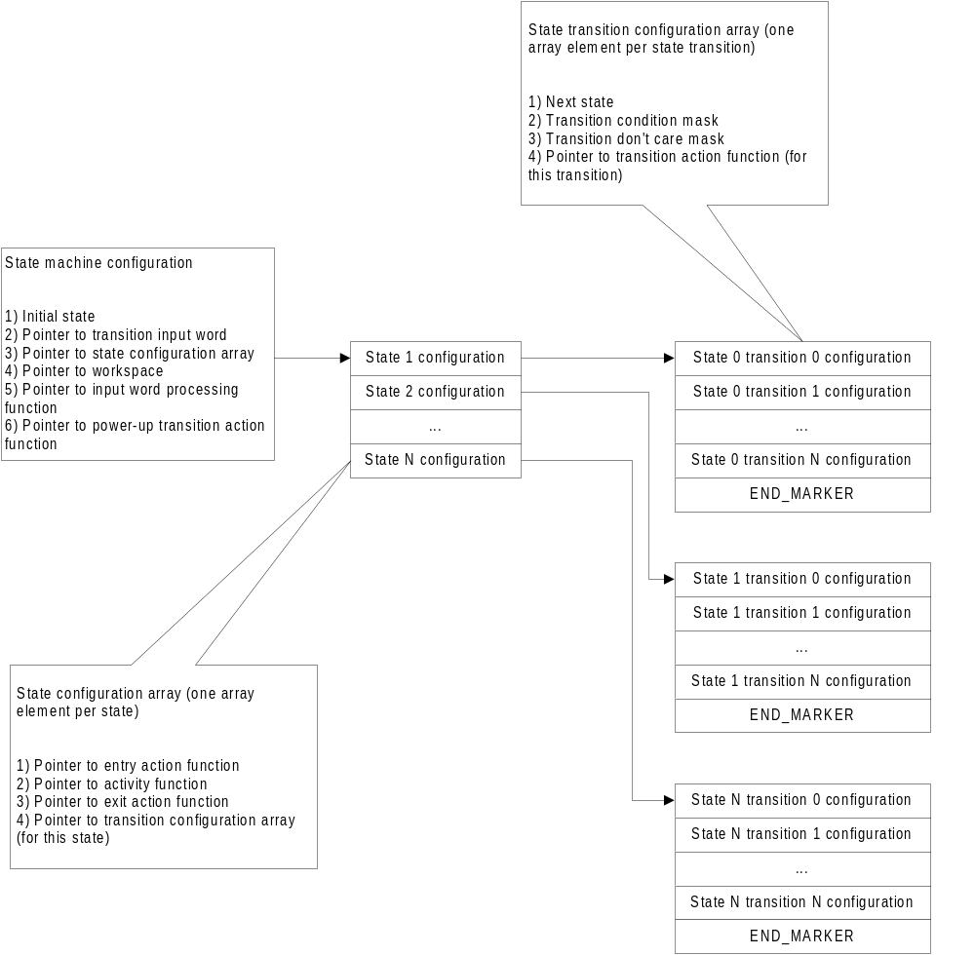
0
1

Public interface
The public interface to the FSM engine consists of some structure data types and functions. They are described in the following sections.

Functions
- void fsm_init(const FSM_CONFIG_T *fsm_config_ptr);
- void fsm_process(const FSM_CONFIG_T *fsm_config_ptr);

- void fsm_timer1_enable(U32_T timeout, const FSM_CONFIG_T *fsm_config_ptr);
- void fsm_timer1_new_timeout(U32_T timeout, const FSM_CONFIG_T *fsm_config_ptr);
- void fsm_timer1_disable(const FSM_CONFIG_T *fsm_config_ptr);
- void fsm_timer1_stop(const FSM_CONFIG_T *fsm_config_ptr);
- void fsm_timer1_start(const FSM_CONFIG_T *fsm_config_ptr);
- U32_T fsm_timer1_get_elapsed(const FSM_CONFIG_T *fsm_config_ptr);

- void fsm_timer2_enable(U32_T timeout, const FSM_CONFIG_T *fsm_config_ptr);
- void fsm_timer2_new_timeout(U32_T timeout, const FSM_CONFIG_T *fsm_config_ptr);
- void fsm_timer2_disable(const FSM_CONFIG_T *fsm_config_ptr);
- void fsm_timer2_stop(const FSM_CONFIG_T *fsm_config_ptr);
- void fsm_timer2_start(const FSM_CONFIG_T *fsm_config_ptr);
- U32_T fsm_timer2_get_elapsed(const FSM_CONFIG_T *fsm_config_ptr);

- U8_T fsm_get_current_state(const FSM_CONFIG_T *fsm_config_ptr);
- void fsm_clear_trans_history(const FSM_CONFIG_T *fsm_config_ptr);

void fsm_init(const FSM_CONFIG_T *fsm_config_ptr);
This initializes a state machine defined by the passed state machine configuration. This should be called upon powerup.

void fsm_process(const FSM_CONFIG_T *fsm_config_ptr);
This processes a state machine defined by the passed state machine configuration. This should be called periodically.

void fsm_timer1_enable(U32_T timeout, const FSM_CONFIG_T *fsm_config_ptr);
This enables timer 1 of the state machine defined by the passed state machine configuration. The timeout is in ticks where ticks corresponds to the rate that the state machine is processed (by a fsm_process function call). This should be called as needed by state entry action, exit action, transition action, and activity functions.

void fsm_timer1_new_timeout(U32_T timeout, const FSM_CONFIG_T *fsm_config_ptr);
This assigns a new timeout for timer 1 of the state machine defined by the passed state machine configuration. The timeout is in ticks where ticks corresponds to the rate that the state machine is processed (by a fsm_process function call). This should be called as needed by state entry action, exit action, transition action, and activity functions.

void fsm_timer1_disable(const FSM_CONFIG_T *fsm_config_ptr);
This disables timer 1 of the state machine defined by the passed state machine configuration. This should be called as needed by state entry action, exit action, transition action, and activity functions.

void fsm_timer1_stop(const FSM_CONFIG_T *fsm_config_ptr);
This stops timer 1 (i.e. without disabling the timer) of the state machine defined by the passed state machine configuration. This is used in conjunction with the fsm_timer1_start function. This should be called as needed by state entry action, exit action, transition action, and activity functions.

void fsm_timer1_start(const FSM_CONFIG_T *fsm_config_ptr);
This restarts timer 1 of the state machine defined by the passed state machine configuration. This is used in conjunction with the fsm_timer1_stop function. This should be called as needed by state entry action, exit action, transition action, and activity functions.

U32_T fsm_timer1_get_elapsed(const FSM_CONFIG_T *fsm_config_ptr);
This returns the current timer1 value. This should be called as needed by state entry action, exit action, transition action, and activity functions.

void fsm_timer2_enable(U32_T timeout, const FSM_CONFIG_T *fsm_config_ptr);
This enables timer 1 of the state machine defined by the passed state machine configuration. The timeout is in ticks where ticks corresponds to the rate that the state machine is processed (by a fsm_process function call). This should be called as needed by state entry action, exit action, transition action, and activity functions.

void fsm_timer2_new_timeout(U32_T timeout, const FSM_CONFIG_T *fsm_config_ptr);
This assigns a new timeout for timer 1 of the state machine defined by the passed state machine configuration. The timeout is in ticks where ticks corresponds to the rate that the state machine is processed (by a fsm_process function call). This should be called as needed by state entry action, exit action, transition action, and activity functions.

void fsm_timer2_disable(const FSM_CONFIG_T *fsm_config_ptr);
This disables timer 1 of the state machine defined by the passed state machine configuration. This should be called as needed by state entry action, exit action, transition action, and activity functions.

void fsm_timer2_stop(const FSM_CONFIG_T *fsm_config_ptr);
This stops timer 1 (i.e. without disabling the timer) of the state machine defined by the passed state machine configuration. This is used in conjunction with the fsm_timer2_start function. This should be called as needed by state entry action, exit action, transition action, and activity functions.

void fsm_timer2_start(const FSM_CONFIG_T *fsm_config_ptr);
This restarts timer 1 of the state machine defined by the passed state machine configuration. This is used in conjunction with the fsm_timer2_stop function. This should be called as needed by state entry action, exit action, transition action, and activity functions.

U32_T fsm_timer2_get_elapsed(const FSM_CONFIG_T *fsm_config_ptr);
This returns the current timer2 value. This should be called as needed by state entry action, exit action, transition action, and activity functions.

U8_T fsm_get_current_state(const FSM_CONFIG_T *fsm_config_ptr);
This returns the current state of the state machine defined by the passed state machine configuration. The value returned is equal to the #defined index value described in section 4.1. Typically, this would be called by a state machine's input word processing function or outside of the state machine for software development purposes.

void fsm_clear_trans_history(const FSM_CONFIG_T *fsm_config_ptr);
This clears the last input word value and the last condition mask value to allow the next transition check to cause a transition if the check is true. This basically overrides the race condition protection described in section 3.3. This should be called as needed by state entry action, exit action, transition action, and activity functions.

Data types
Data types:
- FSM_TRANS_CONFIG_T
- FSM_STATE_CONFIG_T
- FSM_CONFIG_T
- FSM_WORKSPACE_T

FSM_TRANS_CONFIG_T
State transition configuration data type. It consists of the following members:
- U8_T next_state;
- U32_T trans_cond_mask; /* Transition condition mask (use 0 for don't care bits) */
- U32_T trans_dont_care_mask; /* Transition don't care mask to indicate don't care conditions with a 0 */
- void (*trans_funct_ptr)(void); /* Function to run upon state transition to next state */

FSM_STATE_CONFIG_T
State configuration data type. It consists of the following members:
- void (*entry_action_funct_ptr)(void); /* Function to run upon state entry */
- void (*activity_funct_ptr)(void); /* Function to run while in the state */
- void (*exit_action_funct_ptr)(void); /* Function to run upon state entry */
- FSM_TRANS_CONFIG_T *state_trans_config_ptr; /* Pointer to current state transition config */

FSM_CONFIG_T
Main state machine data type. It consists of the following members:
U8_T initial_state;
U32_T *trans_input_ptr;
FSM_STATE_CONFIG_T *state_config_ptr;
FSM_WORKSPACE_T *workspace_ptr;
void (*process_inputs_funct_ptr)(void); /* Function to process the input word bits */
void (*power_up_trans_funct_ptr)(void); /* Function to run at power up if needed */

FSM_WORKSPACE_T
State machine workspace data type. The workspace is used internally by the FSM engine. It consists of the following members:
U32_T timer1;
U32_T timer1_timeout;
U32_T timer1_timeout_backup;
U32_T timer2;
U32_T timer2_timeout;
U32_T timer2_timeout_backup;
U32_T last_input_word; /* Last input word */
U32_T last_event_trans_cond_mask; /* Last condition mask that caused an event */
U8_T timer1_enable; /* Indicates whether timer1 is enabled or not */
U8_T timer2_enable; /* Indicates whether timer2 is enabled or not */
U8_T current_state;
U8_T transition; /* Flag to indicate that a transition just occurred */

Instantiated state machine
A state machine is instantiated by defining a state machine configuration and calling the FSM engine initialization (fsm_init) and process (fsm_process) functions appropriately.

Public interface
A state machine's public interface consists of the following:

- #defined list of states
- state machine configuration
- optional signal functions

An example of a #defined list of states for a CD play state machine would be as follows:
#define STANDBY 0
#define PLAY_CD 1
#define EJECT_CD 2
etc.

The value defined in the list above is the value returned by the fsm_get_current_state function (see section 3.9.1.9).

Note: The value assigned to the state must be the same as the index of the state in the state configuration array (see section 3.8.2).

Files
A state machine is implemented using five files as follows:

- <state machine name>_fsm_config.c
- <state machine name>_fsm_functs.c
- <state machine name>_fsm_input.c
- <state machine name>_fsm_private.h
- <state machine name>_fsm_public.h

Each of these files is described in the following sections.

<state machine name>_fsm_config.c
This file contains the allocation of the state machine workspace. It also contains the constant allocation of the state machine configuration which includes the main state machine configuration, state configuration array, and state transition configuration arrays.

<state machine name>_fsm_functs.c
This file contains the implementations of the state activity functions, entry action functions, exit action functions, and the state transition action functions. It also contains any variables or functions internal to the state machine required by the state machine logic.

<state machine name>_fsm_input.c
This file contains the allocation of the state machine input word variable. It also contains the implementations of the state machine input word processing function and the state machine signal functions.

<state machine name>_fsm_private.h
This file contains any #defined symbols internal to the state machine required by the state machine logic. It also contains an extern of the state machine input word variable. In addition, it contains prototypes for the input word processing function, state activity functions, entry action functions, exit action functions, state transition action functions, and any other variables or functions internal to the state machine required by the state machine logic.

<state machine name>_fsm_public.h
This file contains the #defined list of states, the extern of the state machine configuration, and the prototypes of the optional state machine signal functions.

